Black Holes:
Gravity to the Extreme

Tanner Lewis

Introduction
Gravity is the weakest force of the four fundamental forces, which include Strong Nuclear, Weak Nuclear, and Electromagnetism. Gravity is weaker than electricity by a factor of 10⁴⁰. Sir Isaac Newton was the first to explain this magnificent force of nature. He was eventually corrected by Albert Einstein in 1915. When Einstein published the General Theory of Relativity which said when an object with enough mass was set in space, it would distort space-time. This distortion was gravity. When Einstein theorized Relativity, he also theorized the idea of a black hole. A black hole has a mass so great that even light cannot escape the distortion, gravity, that the black hole creates, thus making it ‘black.’ Black holes are captivating to the scientific community and especially to physicists because they present an opportunity to observe gravity to its extreme. Now to start at the beginning with Relativity.
Gravity: The Foundations of Black Holes
In 1915 Einstein wrote the General Theory of Relativity in order to explain gravity. Einstein’s own theory was so complex he could not solve the mathematics behind it. Thankfully he didn’t have to. In that same year, Karl Schwarzschild solved Einstein’s Theory. This solution was the first theoretical description of a black hole. Sir Arthur Eddington wasn’t satisfied with just a solved equation, he wanted direct evidence. In order to do this, he had to watch a solar eclipse and observe the position of a star. If the star’s apparent position changed during the eclipse, then the light bent to the gravity of the sun. If not, then the theory of Relativity was incorrect. Eddington traveled around the world to witness an eclipse. From his observations, he was able to prove that Relativity was accurate. These observations and events changed the way that the world thought about gravity. Eddington’s observations are direct evidence that black holes could theoretically exist. These three men laid the foundation for the modern idea of a black hole. (Avery Broderick 5/2/19)
The Definition of a Black Hole
Before continuing, it is necessary to define terms as they relate to black holes. A Black Hole is a compact group of matter in which the escape speed is greater than the speed of light (Gravity’s Fatal Attraction). To define more specifically, a black hole is a compact group of matter. We don’t know exactly what makes up the mass of the black hole, other than what it ‘consumes’, which is stars asteroids and basically everything that passes the event horizon. So, just think about the interior of a black hole like a dark star. It has the properties of a star but with a mass so large that light cannot escape.
Escape Speed is essential to a black hole. It builds off of the mass of a black hole also. In short, everything with mass has a gravitational field. Sometimes that field is so small in comparison to another that you don’t notice it. For instance, my body mass has an incredibly small gravitational field when compared to the earth. The earth has an escape speed of 40,000 kph or 24,855 mph. The sun has an escape speed 100x that. Here is an example of escape speed in action. Imagine you have a cannon. You aim the cannon straight up. If you were to shoot that cannon ball up at 100 mph it would eventually fall down, because the escape speed of the earth was greater than the speed of the cannon ball. If you shot the cannon ball at 500 mph, it would go up farther, but it still wouldn’t be able to escape earth’s gravitational field. If you were to shoot the cannon ball at 24,000 mph you would be closer to getting the ball out of the gravitational field, but it still wouldn’t be enough. You would have to shoot it at or more than 24,855 mph. Think about that cannon ball as light. A black hole has an escape speed greater than the speed of light. Thus, the name black hole.
A few other things necessary to define are the event horizon, singularity, space time, relativistic jets, accretion disk, and photon sphere.
The Event Horizon: In any fictional movie concerning black holes this is always known as “The point of no return” And that is probably the most or only true thing about black holes you will learn about in that movie. The escape speed of any object becomes increasingly higher as you get closer to it (Gravity’s Fatal Attraction). The same thing is true about black holes. The event horizon is the point at which the escape speed is greater than the speed of light. Here is the number one thing to remember if you were ever to encounter a black hole in person. If you get sucked past the event horizon, more on this later, you’re not going to find yourself on the other side of the universe. Instead, you’ll most likely be standing in front of the judgement seat. If you were to pass the event horizon, without being instantly killed, you would be inevitably drawn to the singularity. And that leads to the next term I want to define.
The singularity: The definition of singularity in relation to black holes is, the point in which gravity is infinitely strong (Shep Doeleman) Remember this because it will be crucial when we talk about the first skeptics of the black hole.
Space time is an idea that Einstein discovered soon after the General Theory of Relativity. In simple terms, space time is a straight line that gets bent by matter like stars, planets, galaxies, black holes, and basically anything with significant mass. This is what Eddington was trying to prove when he traveled to view an eclipse. If the apparent position of the star was different than where it was before the eclipse, then the sun was bending the light of the star or you could say making a dent in space time.
Relativistic jets are jets of matter spewing out of the north and south poles of the black hole. The matter that gathers is in these jets are super-heated to thousands of degrees due to the friction between the atoms. This matter, likely gas, and space dust, is then shot out of the jets anywhere from 50% to 99% of the speed of light (EHT). This matter is then distributed thousands of light years across space extending farther than even the galaxy the black hole is located in. No one knows how these jets form, but organizations like NASA and The Event Horizon Telescope are currently studying black holes in a new light with technology that will be described shortly.
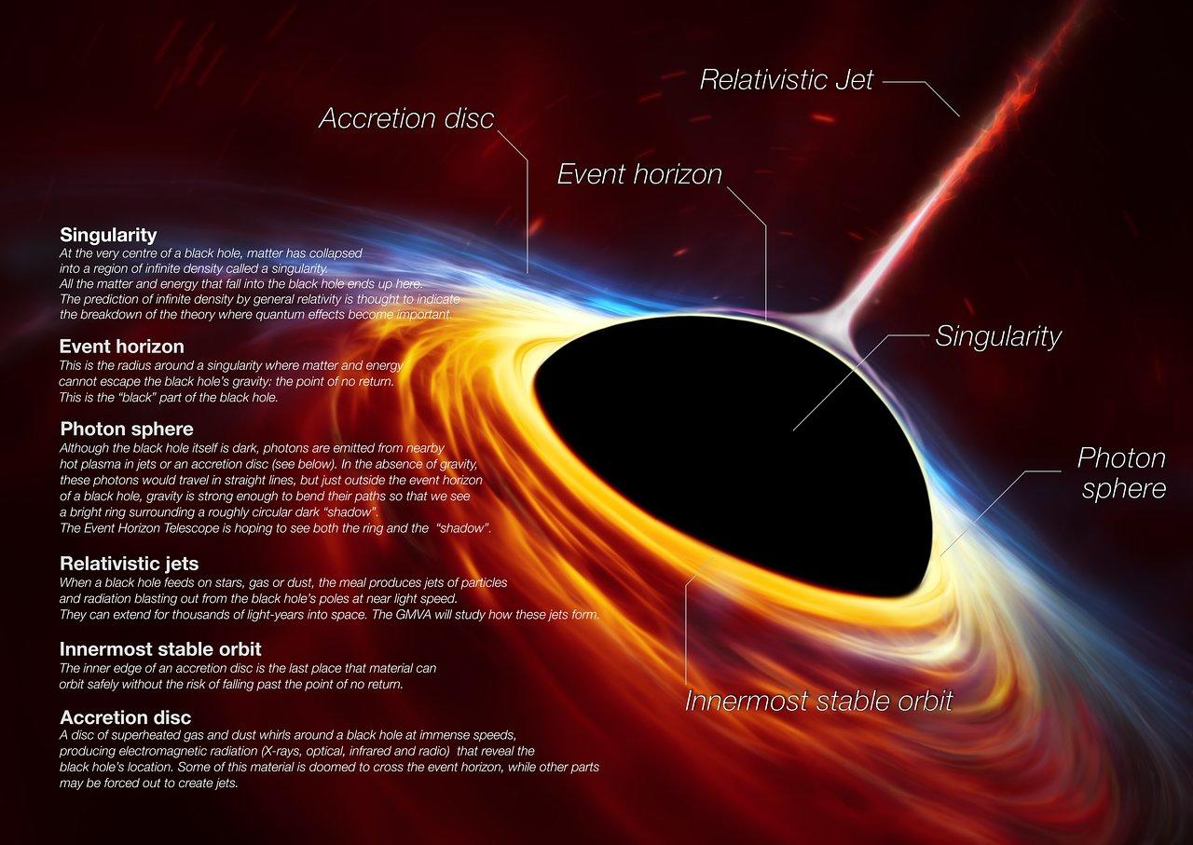
Fig. 1. Diagram of a Black Hole (Event Horizon Telescope)
Accretion disk: This part of the black hole is vital to our ability to observe this incredible object. The accretion disk, as shown in Fig. 1, is a ring-like disk of matter that is orbiting the black hole. Since a black hole has an escape speed greater than the speed of light, the light produced by the accretion disk and photon sphere enable us to see the shadow of a black hole.
The photon sphere is the last orbit that light takes before being brought past the event horizon. The photons being emitted by the photon sphere would usually travel in a straight line, but because of the photon’s proximity to the black hole the gravitational pull is strong enough to put those photons into orbit. An interesting fact about the accretion disk and photon sphere is that the closer you get to the event horizon the faster the accretion disk or photon sphere spins. The Accretion Disk is the reason that we can observe black holes.
These are the components of a black hole. Even though we don’t know much concerning black holes we know that these things exist because we can see them from direct observation using satellites and radio imaging.
Skepticism of Black Holes
One of the first theories regarding the birth of a black hole was created by Robert Oppenheimer and Hartland Snyder in 1939. They suggested that the implosion, not explosion, of a dying star could theoretically form a black hole. Physicists were skeptical of Oppenheimer and Snyder’s Theory. Their reasons for skepticism were understandable. Oppenheimer and Snyder’s theory assumed that the imploding star was perfectly symmetrical and non-rotating without blemish or imperfection. We know that no star is perfectly symmetrical and non-rotating (Gravity’s Fatal Attraction pg. 11). Most of the physicists said that they had a feeling that any imperfection would be amplified during the collapse. Different parts of the star wouldn’t hit each other, and no horizon would form. They believed that the result of this chaotic collapse would produce some intermediate mess of something between a black hole and a supernova.
One of the other reasons for the Physicists’ skepticism is the presence of a singularity. Remember when we talked about the singularity earlier, we said it was the point in a black hole where gravity is the strongest. Now we never said what the escape speed of a black hole is. We’ve already said that it is greater than the speed of light. But in order to fully understand what physicists’ problems were with black holes we have to take a deeper dive into escape speed, and more specifically the speed of light in a vacuum. The speed of light is dependent upon the resistance of the air and the materials that are blocking it. These things slow light down. But, when you put light in a vacuum it has nothing slowing it down, making it go infinitely fast. Since light in a vacuum goes infinitely fast, a black hole has an escape speed as infinite as the speed of light in a vacuum. Thus, the singularity of the black hole has a point, the singularity, in which gravity is infinitely strong. For as Newton said, “For every action there is an equal and opposite reaction.” This is the problem that physicists had with a black hole. If a black hole existed, then gravity would be infinite. Usually when you encounter something as extraordinary as this, scientists label it as a mistake in the equation not as something special God created in His universe.
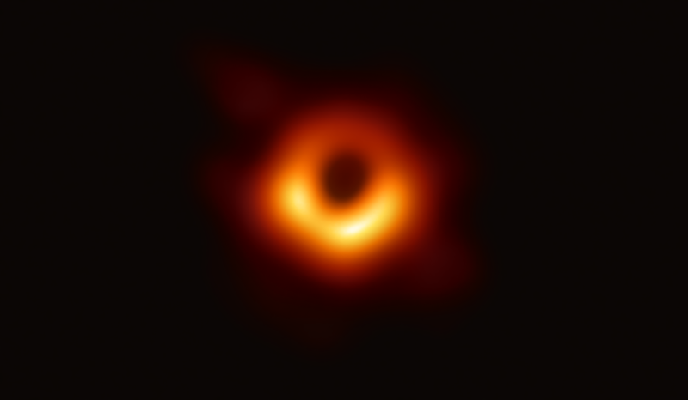
Fig. 2. First ever image of a Black Hole (Event Horizon Telescope)

The Event Horizon Telescope
Fast forward 80 years and now we have the first image of a black hole. In April of 2019 the Event Horizon Telescope (EHT) published the first ever photo of a black hole (Fig. 2), and more recently in March of 2021 a photo of the magnetic fields revolving around black hole M87 (Fig. 3). If you look at Fig. 2 you will see the photon sphere and the “shadow” of the black hole.
The EHT is a global organization consisting of scientists and astronomers from dozens of countries. The way that EHT gets an image is not as easy as staring up at the sky looking for a black hole finding one and taking a picture with your phone. To give you an accurate idea of how hard this was for the EHT, just imagine that you are standing in New York City to take a picture of a black hole with relatively good resolution you would need to be able, from your position in NYC, to read the date on a quarter in Los Angeles. To make it even more complicated, if you did want to read the date on a quarter in LA from NYC you would need to build a telescope the size of the earth (Shep Doeleman, 9/6/19).
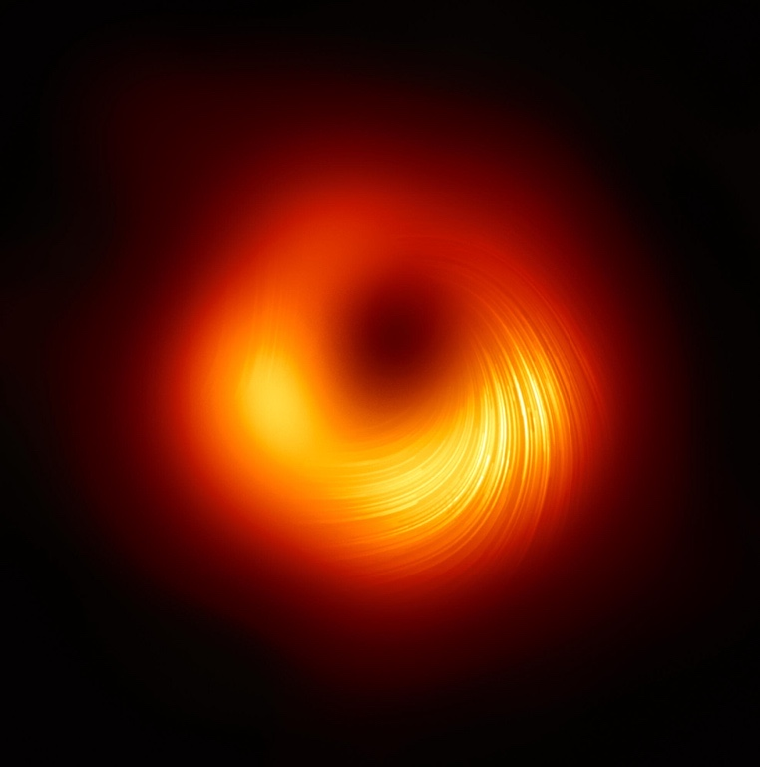
Fig. 3. Magnetic fields surrounding black hole M87 (Event Horizon Telescope)
So, how do you build a telescope the size of earth? Obviously, you can’t literally make a telescope the size of the world. So, the real question is how do you effectively make a telescope the size of earth? First, we have to cover how a regular telescope works.
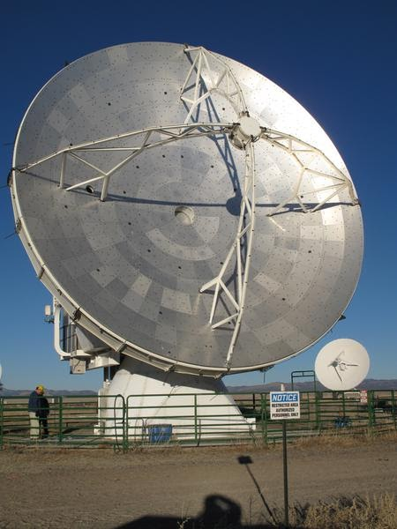
Fig. 4. Greenland Telescope Project (Event Horizon Telescope)
A radio telescope like the GTP in Fig. 4 uses a dish to bounce light into the receptor. The EHT couldn’t build a dish the size of earth, instead they took multiple telescopes around the earth and used them to bounce light up to a single point. But it didn’t make sense to bounce all of that light up to a receptor above the earth, so they got the data, stored it on hard-drives and took it to a central location called a correlator. In order to get an accurate image, EHT has to time tag each data set perfectly. They use Hydrogen maser clocks (Atomic clocks) that only lose one second every ten million years. This process of making an earth sized telescope is called Very Long Baseline Interferometry or VLBI for short (Shep Doeleman 9/6/19)

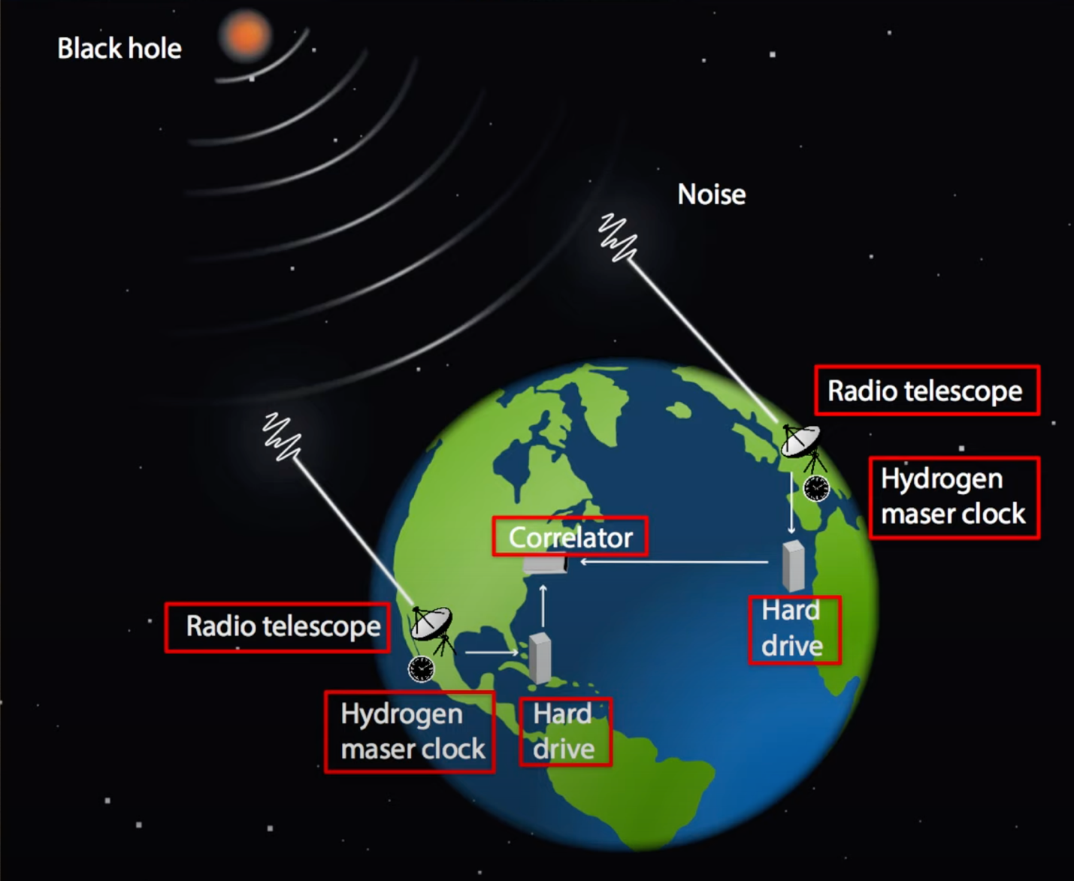
Fig. 5. How EHT makes an earth sized Telescope (Event Horizon Telescope)
This wasn’t the end of the troubles EHT had to endure. They also had to find the right algorithm to input all the data into. In order to prevent human bias, they split the team into four different teams. Gave them the data and sent them into isolation. They all came out of their seven-week isolation period with the same image, different algorithms but the same image. Then, in order to double check their work, they tried to make the image go away. They put fake datasets into the algorithms in order to see if the fake data came out as what was put in. To illustrate this better take a look at Fig. 6. They put in a fake dataset resembling object 1 and saw if it came out as object 1 or if it came out as something the data wasn’t.
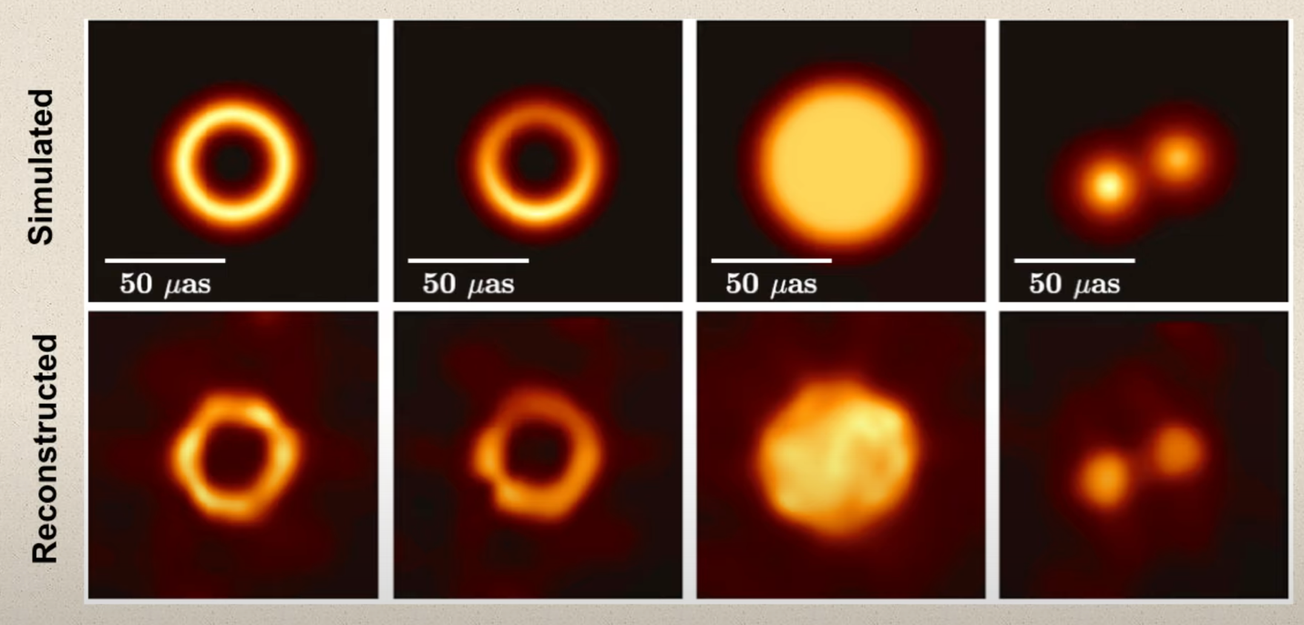
1 2 3 4
Fig. 6. Fake dataset representations before entered into the algorithm (Event Horizon Telescope)
All of the data came out perfectly. The Event Horizon Telescope had in fact found and imaged a black hole. EHT actually had the data two years before they released the image shown in Fig. 2. The process just described took two full years to complete. To clarify, EHT did not actually find black hole M87. The M in M87 stands for Messier which is the last name of Charles Messier. Charles Messier was a comet hunter in the 1700’s. During his travels he made a list of things that were not comets, M87 is the 87th entry in that list.
Conclusion
Black holes seem to be unimportant objects in our universe. Most people walk into this topic thinking this is interesting, but how does this affect me? Gravity is the weakest force and black holes are the only known object in the universe where gravity is the defining force. Plus, understanding black holes is critical to our understanding of relativity and quantum mechanics. These two theories have not been proven to be compatible or incompatible. Considering gravity is the primary focus of Relativity it would make sense that gravity to the extreme would be vital to our understanding of these two concepts. Not only do black holes present the opportunity to reconcile relativity and quantum mechanics but black holes also form your galaxy. Don’t believe it? At the middle of the Milky Way Galaxy is Black Hole Sagittarius A*. This black hole has dozens of stars revolving around it in unstable unpredictable orbits.
Black Holes are captivating objects that have puzzled astronomers and physicists for decades. Now that we have new technology and techniques it is becoming easier to study and observe black holes. It will not be long before the event horizon telescope will be able to create full scale movies and videos of black holes. As we continue to learn about black holes, we will increasingly learn more about gravity. Black holes truly are gravity to the extreme.

Works Cited
Nasa “Active Galactic Nuclei” Nasa.gov. Nasa, 6 April 2006. Web. 6 April 2006.

Doeleman, Shep. “2020 Breakthrough Prize Winner Shep Doeleman—How EHT Imaged

a Black Hole” World Science Festival. Web. 6 September 2019. Speech.

Event Horizon Telescope “Press Release (April 10, 2019): Astronomers Capture First Image of a

Black Hole” eventhorizontelescope.org. Event Horizon Telescope, 10 April 2019. Web. 10 April 2019.

Mitchel, Begelman, and Martin Rees. Gravity’s Fatal Attraction (Black Holes in the Universe).

Cambridge: University Printing House, 2021. Print.

Redd, Nola. What are Black Holes? 11 July 2019. Web. 11 July 2019.

Greshko, Michael. Closest Black Hole found hiding in ‘plain sight’. 6 May 2020. Web. 6 May

2020.

Herbert, Jake. First ever photo of a Black Hole. 23 April 2019. Web. 23 April 2019.

Broderick, Avery. “Avery Broderick Public Lecture: Images from the Edge of Spacetime”.
Perimeter Institute for Theoretical Physics. 4 October 2018. Speech.

